**Cultural, Historical, & Gender Humility: Email Support**

Greetings team,

*(Insert introduction of workshop and overall context of how a trauma-informed approach will be rolled out in the organization or project. Share timeline of what has happened and will happen, including frequency of workshops being offered and topics that have been/will be included.)*

Suggested language: Each workshop will focus on one of the principles and will offer three action-oriented tips to help bring the principle to life. In addition, we will be sharing follow-up emails to reinforce those tips. Topics covered in workshops so far include ______. The most recent workshop focused on cultural, gender, and historical humility. Below are some tips on how to implement this principle in your practice.

**Cultural, Historical, & GenderHumility definition**

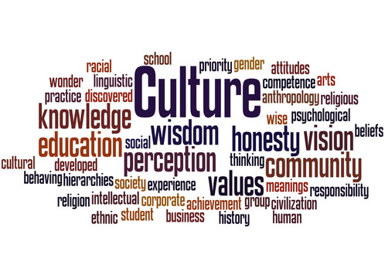

(you may want to include the word cloud from your workshop here or you can use the graphic provided)

“The organization actively moves past cultural stereotypes and biases (e.g. based on race, ethnicity, sexual orientation, age, religion, gender- identity, geography, etc.); offers, access to gender responsive services; leverages the healing value of traditional cultural connections; incorporates policies, protocols, and processes that are responsive to the racial, ethnic and cultural needs of individuals served; and recognizes and addresses historical trauma.”

<https://www.cdc.gov/cpr/infographics/6_principles_trauma_info.htm>

**Tip 1: Believe People**

Why?

Consider the quote by Brene Brown, “We need to dispel the myth that empathy is 'walking in someone else's shoes.' Rather than walking in your shoes, I need to learn how to listen to the story you tell about it's like in your shoes and believe you even when it doesn't match my experiences” as a way to think about believing people. Believe people when they tell you about their experience/s. Recognize that everyone has different perceptions based on their life experiences and identity.

How can we do it?

* Check yourself
* Center the other person’s experience
* Don’t correct, minimize, or compare
* Be curious
* Listen
* Accept

**Tip 1 in action:**

Be aware of your own biases and immediate judgements–we all have them. Take a pause and really listen to understand. Choose to believe the person is communicating what they experienced accurately and know that your job is not to agree or disagree but rather to listen.

**Tip 1 resource:**

**Empathy – Accept Others for Who They Are**

<https://www.conovercompany.com/empathy-accept-others-for-who-they-are/#:~:text=Acceptance%20is%20the%20ability%20to,your%20desire%20to%20change%20them>.

**Tip 2: Identify & Honor Needs**

Why?

Recognizing that people’s behaviors, thoughts, and emotions are communication about an unmet need is a pillar of applying a trauma-informed approach. To create an inclusive environment and culture, we can pause and identify what we need in the moment. Are we hungry? Tired? Lonely? Feeling out of control? Feeling Misunderstood? Unsafe? Disconnected? Alone? When we identify needs and communicate them, we can honor them.

How can we celebrate?

* Create a DEIB committee
* Review policies, procedures, and environment
* Get feedback about people’s needs
* Follow the diversity calendar
* Organize a potluck

**Tip 2 in action:**

Remember that a trauma-informed approach starts with you. When you are aware of your own needs, you can communicate them. When you are aware of others’ needs, you can aim to honor and meet them. It is not our job to judge or decide what is correct or incorrect. We can take this chance to celebrate and connect with one another.

**Tip 2 resource:**

**12 Diversity, Equity, & Inclusion Activities-**

<https://snacknation.com/blog/diversity-inclusion-activities/>

**Tip 3: Be a learner, not a knower**

Why?

Cultural humility is the practice of knowing that you don’t know about someone else’s experiences. The quote, “As you shift from knower to learner, you become open to consider new possibilities” can be a conversation starter for participants. You can define a learner as someone who has an open mind or a “beginner’s mind” in contrast to a knower as someone who believes that they already know everything about a topic or have the correct answer or are doing things the right way. There is often more than we can process in our first observation of a situation. This tip encourages us to zoom out and notice, with a non-judgmental lens, what we notice so that we can learn.

How can we do it?

* Practice humility
* Listen to people’s experience
* Be curious

**Tip 3 in action:**

This week, try leading with the questions, *What? When? Where? And How? Use open-ended questions or the prompts, tell me more about that? You can also ask someone if you missed anything or if they have anything additional they see, hear, think about in a situation. Be an observer and notice with a non-judgmental perspective what is around you. You may see things differently, too!*

**Tip 3 resource:**

Be a learner, not a knower-

<https://www.linkedin.com/pulse/revisiting-growth-mindset-knower-vs-learner-nikhil-tayal/>

Shift from a knower mind to a learner’s mind-

<https://theempowermentdynamic.com/shift-from-a-knower-mind-to-a-learners-mind/>