**Strengths Based: Email Support**

Greetings team,

*(Insert introduction of workshop and overall context of how a trauma-informed approach will be rolled out in the organization or project. Share a timeline of what has happened and will happen, including frequency of workshops being offered and topics that have been/will be included.)*

Suggested language: Each workshop will focus on one of the principles and will offer three action-oriented tips to help bring the principle to life. In addition, we will be sharing follow-up emails to reinforce those tips. Topics covered in workshops so far include ______. The most recent workshop focused on strengths-based. Below are some tips on how to implement this principle in your practice.

**Strengths Based definition**

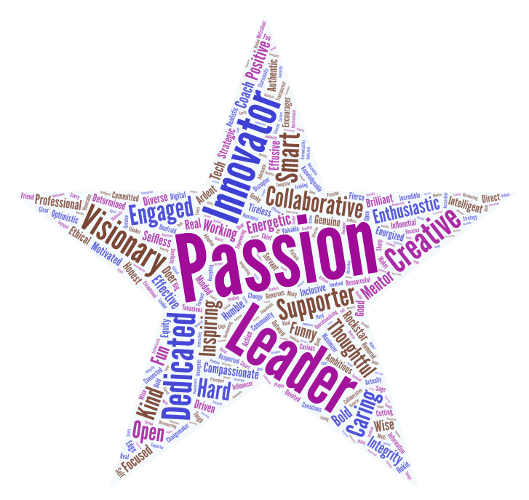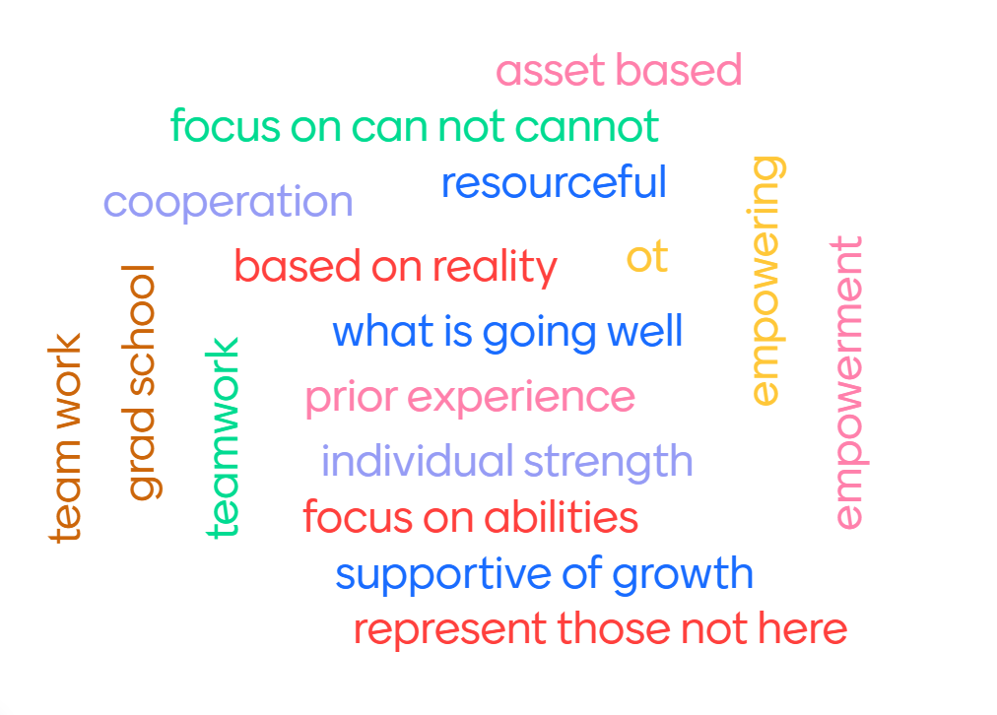

(you may want to include the word cloud from your workshop here or you can use the graphic provided)

Strengths-based approach centers the strengths and resilience of people, communities, and their environments in building a trauma-informed culture. Rather than viewing adaptations to life experiences as problems, they are seen as solutions and part of the journey toward healing.

**Tip 1 Practice a Growth Mindset**

Why?

There was a time when we believed that our minds were only able to learn so much before becoming stuck in a sort of automatic mode of operating. Neuroplasticity–the ability of the nervous system to change its activity in response to learning even after injuries or traumatic experiences–teaches us that you can teach an old dog new tricks. When we rewire the brain, we can create new habits. Carol Dweck, the founder of a growth mindset, explains that people who practice this approach to life, “embrace challenges because they believe that they can learn from experiences, develop their skills, and improve with practice – all of which can lead to greater achievement.”

How can we do it?

* Make mistakes (and learn from them)
* Harness the power of “yet”
* Seek feedback
* Try something new
* Be kind to yourself
* Keep going even when it’s hard
* Celebrate others’ successes
* Don’t compare yourself with others

**Tip 1 in action:**

Identify something that you are considering learning more about or are currently in the process of learning (a language, a sport, a hobby, etc). As you are practicing or gaining more information about the topic, you may find yourself discouraged or unmotivated. You can use the phrasing, “I haven’t learned how to _____ yet” or “I am in the process of learning ___.” This can help regulate us when times get stressful so we keep moving through tough times.

**Tip 1 Resource:**

15 Ways to develop a growth mindset

<https://www.psychologytoday.com/us/blog/click-here-happiness/201904/15-ways-build-growth-mindset>

# Developing a Growth Mindset with Carol Dweck (Video)-

<https://www.youtube.com/watch?v=hiiEeMN7vbQ>

# Growth Mindset vs Fixed Mindset: What’s the Difference?<https://www.forbes.com/sites/forbesnonprofitcouncil/2023/04/17/developing-a-growth-mindset-culture/?sh=4285bea05822>

**Tip 2: Own Your Superpower**

Why?

Consider the quote (not by Einstein) that says, “Everybody is a genius. But if you judge a fish by its ability to climb a tree, it will live its whole life believing that it is stupid.” Each of us is built with a unique set of skills. When we learn what those skills are and spend our time and attention on developing them, we can live our purpose. When we know our own superpower, we can offer our support to others and ask other people for help. We can connect with people in the special way that we know how.

How can we do it?

* Know it
* Embrace it
* Do it

**Tip 2 in action:**

If you haven’t yet found your superpower, that’s ok. Keep a growth mindset and keep exploring. We often discover who we are through experiences of who we are not. If you know your superpower, take some time to notice how you can continue to be authentic in how you embrace it and do it. This could mean sharing it with others or exploring other ways that you can practice.

**Tip 2 resource:**

Sensitivity can be a superpower-  
<https://hbr.org/2023/04/sensitivity-can-be-a-superpower-at-work>

Discover your superpower at work- <https://www.forbes.com/sites/dedehenley/2021/03/07/discover-your-superpower-at-work/?sh=75ba65627213>

**Tip 3: Recognize others’ strengths**

Why?

Knowing what you do well is one piece of the puzzle. Identifying the strengths and superpowers of those around you is the next step. Recognizing what other people are good at can help optimize your team. When we outwardly recognize the strengths of others, we encourage them to continue to develop that skill and become masters in their own craft.

How can we do it?

* Observe nonjudgmentally
* Recognize biases or fears
* Focus on the sparkle
* Acknowledge and appreciate

**Tip 3 in action:**

When you notice someone shining the light of their superpower on someone else, acknowledge them. Tell them that you see them and appreciate them. It’s simple but we so often forget.

**Tip 3 resource:**

# Why Employees Need Both Recognition and Appreciation-

<https://hbr.org/2019/11/why-employees-need-both-recognition-and-appreciation>