**Empowerment, Voice, & Choice: Email Support**

Greetings team,

*(Insert introduction of workshop and overall context of how a trauma-informed approach will be rolled out in the organization or project. Share a timeline of what has happened and will happen, including frequency of workshops being offered and topics that have been/will be included.)*

Suggested language: Each workshop will focus on one of the principles and will offer three action-oriented tips to help bring the principle to life. In addition, we will be sharing follow-up emails to reinforce those tips. Topics covered in workshops so far include ______. The most recent workshop focused on empowerment, voice, and choice. Below are some tips on how to implement this principle in your practice.

**Empowerment, Voice, & Choice definition**

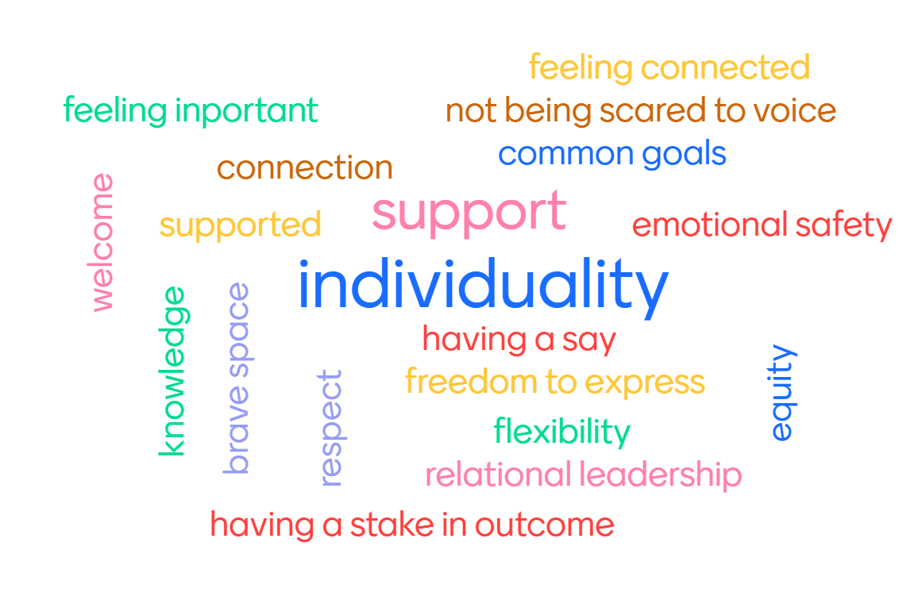

(you may want to include the word cloud from your workshop here or you can use the graphic provided)

“Throughout the organization and among the clients served, individuals’ strengths and experiences are recognized and built upon. The organization fosters a belief in the primacy of the people served, in resilience, and in the ability of individuals, organizations, and communities to heal and promote recovery from trauma. The organization understands that the experience of trauma may be a unifying aspect in the lives of those who run the organization, who provide the services, and/ or who come to the organization for assistance and support. As such, operations, workforce development and services are organized to foster empowerment for staff and clients alike. Organizations understand the importance of power differentials and ways in which clients, historically, have been diminished in voice and choice and are often recipients of coercive treatment. Clients are supported in shared decision-making, choice, and goal setting to determine the plan of action they need to heal and move forward. They are supported in cultivating self-advocacy skills. Staff are facilitators of recovery rather than controllers of recovery. Staff are empowered to do their work as well as possible by adequate organizational support. This is a parallel process as staff need to feel safe, as much as people receiving services.”

Source: <https://www.cdc.gov/cpr/infographics/6_principles_trauma_info.htm>

**Tip 1: Be Curious**

Why?

Developing the skill of curiosity helps us overcome our automatic biases of others and can help us stay out of judgment. A non-judgmental environment creates one where people want to communicate their experiences with each other. This also creates a more inclusive environment where people and relationships are the most important asset, and everyone is an expert.

How can we do it?

* Practice being in awe and wonder of the world
* Embrace the fear of trying something new
* Ask “what,” “when,” “where,” or “how” questions
* Don’t take anything personally
* Observe others
* Take risks to and try new experiences

**Tip 1 in action:**

Taking a curious approach starts with keeping your own biases in check. Set the intention this week to approach the world as a beginner. Try this on your commute to work or while observing someone doing a task that you have seen done countless times. Let go of the need to be the person with the correct answer and ask other people for their thoughts, feelings, and experiences. You can practice this with colleagues and patients and notice what you learn.

**Tip 1 resource:**

The Curiosity Factor

<https://www.bristolglobal.com/cup-of-joe/the-curiosity-factor/>.

**Tip 2: Offer choice**

Why?

When we feel like we don’t have a choice, it’s disempowering. While making decisions can be difficult at times (choosing between two unfavorable experiences), offering a choice gives space for autonomy/agency and empowerment. Understanding brain science helps us support people as they are making decisions. When people are in a flipped lid state, they are not making a decision but rather complying with a request. Only a whole brain can process words and make comparisons so if someone’s lid is flipped, they are not choosing their choice. This can be a re-traumatizing experience for people who have a history of disempowerment. Understanding choice through the lens of brain science can help us help people to make decisions that are congruent with their wants and needs.

*Note: Practice connection before compliance. Letting go of control and outcomes can be difficult when we want people to make the decision that we believe is going to help them* heal. Focus on the person and the relationship.

How can we do it?

* Regulate! (get whole-brained)
* Offer choice when possible in:
  + Sequence of events
  + Which event
  + Participation
  + Timing
  + Who is present at the meeting/appointment
  + Location

**Tip 2 in action:**

Identify places where you can offer people choices. If you notice your lid flipping because of a choice someone else is making, take a pause and notice it so that you can get yourself whole-brained and support the relationship and the person. You can communicate your fears and worries alongside your care and concern for them. This can be a tough balance and practice makes progress!

**Tip 2 resource:**

# The Power Of Choice And What Matters Most For The Future Of Work <https://www.forbes.com/sites/tracybrower/2021/02/21/the-power-of-choice-and-what-matters-most-for-the-future-of-work/>

100 Would You Rather Questions for Coworkers- <https://www.signupgenius.com/Business/would-you-rather-questions-coworkers.cfm>

**Tip 3: Trust your people**

Why?

When we can trust people, we can be empowered to do our thing without focusing on other people. Acknowledge barriers to trust including trauma, a person’s or group’s past behavior, and/or organizational culture. Trust is established by finding a shared purpose, is reinforced by consistency, and can be broken by the betrayal of one of these. Rebuilding trust requires owning that the betrayal occurred and making a commitment to do something different moving forward. The quote by Simon Sinek, “A team is not a group of people who work together. A team is a group of people who trust each other” can be a conversation starter for participants.

How can we do it?

* Listen to people’s experience
* Share responsibility
* Encourage autonomy
* Establish clear plans, expectations, and goals
* Identify clear roles and responsibilities
* Celebrate
* Repair when harm is done

**Tip 3 in action:**

When you notice yourself holding tight onto control of something or having a hard time handing something over to a teammate, lean into that discomfort and let go. That is a practice of trust. Consider opportunities where you can trust your teammates to help you or to get things done.

**Tip 3 additional resource:**

Empathy: The Human Connection- <https://www.youtube.com/watch?v=cDDWvj_q-o8>