**Collaboration & Mutuality: Email Sequence**

Greetings all,

“No one can whistle a symphony; it takes a whole orchestra” ~H.E. Luccock

We continue the journey to integrate a trauma-informed and resilience-building approach into our work. As part of this process, the champions team has been attending bi-monthly workshops to help operationalize the principles of a trauma-informed approach: safety, trustworthiness & transparency, peer support, collaboration & mutuality, empowerment, voice, & choice, and strengths-based. CommuniCare’s DEI group will be leading the workshop focused on cultural, historical, and gender humility.

Each workshop focuses on one of the principles and offers three action-oriented tips to help bring the principle to life. In addition, you will receive these follow-up emails to reinforce those tips. The most recent workshop focused on Collaboration & Mutuality. See below for some tips on how to bring these concepts to life and to view the awesome word cloud describing collaboration and mutuality created by the champions team!

**Collaboration & Mutuality definition**

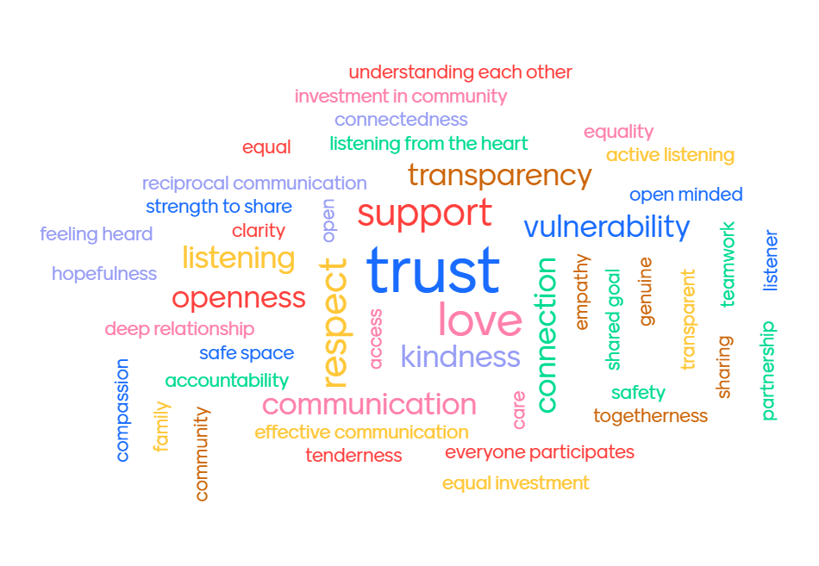

“Importance is placed on partnering and the leveling of power differences between staff and clients and among organizational staff from clerical and housekeeping personnel to professional staff to administrators, demonstrating that healing happens in relationships and in the meaningful sharing of power and decision-making. The organization recognizes that everyone has a role to play in a trauma-informed approach. As one expert stated: “one does not have to be a therapist to be therapeutic.”

<https://www.cdc.gov/cpr/infographics/6_principles_trauma_info.htm>

**Tip #1: Emphasize your shared purpose**

Why?

Knowing your purpose is good but knowing how your purpose connects to that of your peers is even better! When we share why we do what we do with others (mutuality), it offers a chance for working together (collaboration) to achieve a common goal.

How can we do it?

* Know your why (and share it with others!)
* Make your shared purpose visible
* Set collective intention in everyday activities (team huddles, meetings, etc)

Tip #1 additional resource:

Purpose is good. Shared purpose is better.

<https://hbr.org/2013/03/purpose-is-good-shared-purpose>

**Tip #2: Celebrate!**

Why?

Coming together to share in celebration requires vulnerability. Vulnerability requires feeling safe! It’s a cycle that we encourage in the work of implementing trauma-informed and resilience-oriented healing (TIROH) approaches. Whether you bring the cake or are the one being sung to, participating in personal or professional celebrations can bring us together and create lasting memories of trust and connection. Be sure to be inclusive and to practice the principles within the celebrations to nurture a TIROH culture.

How can we do it?

* To set the tone for the week- “It’s Monday! “
* To acknowledge milestones- “Happy Birthday!”
* To recognize a transition- “Welcome/Goodbye!”
* To highlight individual accomplishments- “You graduated!”
* To bring the team together- “We hit our goal!”
* To have fun- “Spirit week- silly sock day, wild hair day, etc”

Tip #2 additional resource:

Being Vulnerable at Work: Is It Worth the Risk?

<https://www.forbes.com/sites/forbescoachescouncil/2021/05/27/being-vulnerable-at-work-is-it-worth-the-risk/?sh=3b4e7a0d25d1>

**Tip 3: Identify Clear Roles**

Why?

Establishing clear roles within a team allows for flexibility and collaboration. As you get to know your team members, you will identify each person’s strengths. When you improve identification and communication with this information, how the tasks will be achieved will become more efficient.

How can we do it?

* Create clear job descriptions for each role within the team.
* Know your team members’ strengths and challenges.
* Come together to create a clear plan for who is doing what and be flexible!

Tip #3 additional resource:

Eight ways to build collaborative teams <https://hbr.org/2007/11/eight-ways-to-build-collaborative-teams>