**Peer Support: Email Sequence**

Greetings all,

You are almost halfway through this phase of your journey in becoming a Trauma-Informed & Resilience-Oriented Healing organization. This email is one in a series that you have been receiving to help you integrate the trauma-informed principles into your work. Remember that you also can turn to the members of the champions team for support. They have been attending bi-monthly workshops to help operationalize the principles of a trauma-informed approach: safety, trustworthiness & transparency, peer support, collaboration & mutuality, empowerment, voice, & choice, and strengths-based. CommuniCare’s DEI group will be leading the workshop focused on cultural, historical, and gender humility.

Each workshop has focused on one of the principles and offers three action-oriented tips to help bring the principle to life. In addition, these follow-up emails will reinforce those tips. So far, we have focused on safety, trustworthiness and transparency, and (most recently) peer support. See below for some tips on how to bring these concepts to life.

**Peer support definition**

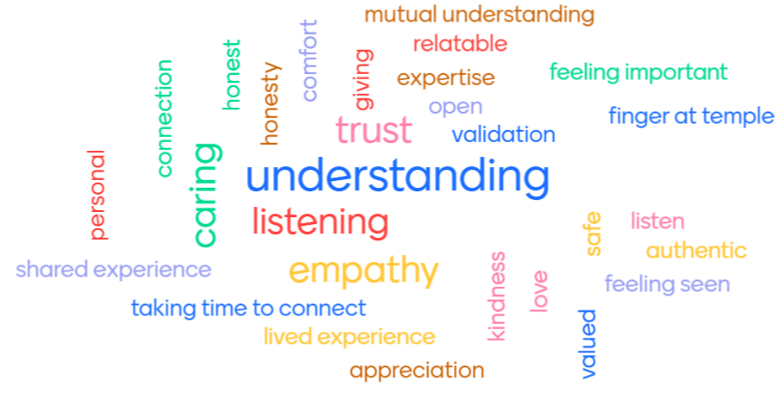

“Peer support and mutual self-help are key vehicles for establishing safety and hope, building trust, enhancing collaboration, and utilizing their stories and lived experience to promote recovery and healing. The term “Peers” refers to individuals with lived experiences of trauma, or in the case of children this may be family members of children who have experienced traumatic events and are key caregivers in their recovery. Peers have also been referred to as “trauma survivors.”

Source: <https://www.cdc.gov/cpr/infographics/6_principles_trauma_info.htm>

**Tip # 1: Identify buddies**

Why?

“Humans need social connection and mutual feelings of vulnerability and stress often create some of the strongest social bonds. In situations like this, the support of colleagues can make a huge difference in your day-to-day wellbeing.”

~Mental Health America

How can we do it?

* Identify someone on your team as a buddy (you can use other language–wellness partner, listening partner, or something else). This can be someone in your department or anywhere within your organization.
* Decide on the time, place, and method of connection–it might be taking a walk break, at lunch, or after a daily huddle. It is preferably in-person, but can also be a virtual chat, email or phone call.
* Remember: You don’t have to be best friends–ust partner up and make a commitment.
* We aren’t always going to be doing great so identify how you agree to communicate with each other if you are worried about safety.

**Tip #1 in action:**

* Share your high moment from the day (the best thing that happened that day)
* Share your low from the day (something that was upsetting)
* Share your “buffalo” (just something random from the day)

Tip #1 additional resource:

Mental Health America- How Healthcare Workers Can Support Each Other

<https://mhanational.org/covid19/frontline-workers>

**Tip #2: Offer appreciation**

Why?

We all need to feel like we matter and to be seen, heard, and connected. Appreciation is one way to show that we are valued as a member of the group. It’s easy and anyone can do it!

How can we do it?

When we offer appreciation, we can consider who we are appreciating and how. Consider the ways below as you implement this practice:

* Words
* Time
* Actions
* Gifts

Tip #2 in action:

You can also simply offer a verbal appreciation to someone. The more specific, the better. See how many you can get in one day. Appreciation can be contagious.

Tip #2 additional resource:

5 Languages of Appreciation in the Workplace <https://www.blueboard.com/blog/in-your-own-words-the-5-languages-of-employee-appreciation>

**Tip #3: Find similarities**

Why?

“Our similarities bring us to a common ground; our differences allow us to be fascinated by each other.”

~Tom Robbins, Novelist

How can we do it?

* Be curious and non-judgmental
* Ask questions
* Offer information about yourself
* Assume best intent in others
* Maintain the boundaries you are comfortable with

Tip #3 in action:

Find something (or things) you have in common with someone. Maybe it’s where you live, an interest or hobby, a group identity, a family role, professional identity, or any skills or strengths you share.

Tip #3 additional resource:

A story of seeking similarities- <https://peopledevelopmentmagazine.com/2020/03/15/beating-isolation-the-search-for-similarities-not-differences/>