**Trustworthiness & Transparency: Email Sequence**

Greetings all,

Happy New Year! To continue the work on becoming a Trauma-Informed & Resilience-Oriented Healing organization, keep your eyes open for emails with tips to help you integrate the trauma-informed principles into your work. As we continue this phase of the journey, the champions team will be attending bi-monthly workshops to help operationalize the principles of a trauma-informed approach: safety, trustworthiness & transparency, peer support, collaboration & mutuality, empowerment, voice, & choice, and strengths-based. CommuniCare’s DEI group will be leading the workshop focused on cultural, historical, and gender humility.

Each workshop will focus on one of the principles and will offer three action-oriented tips to help bring the principle to life. In addition, we will be sharing follow-up emails to reinforce those tips. The first workshop focused on safety and the most recent workshop focused on trustworthiness and transparency. See below for some tips on how to bring these concepts to life.

**Trustworthiness & Transparency definition**

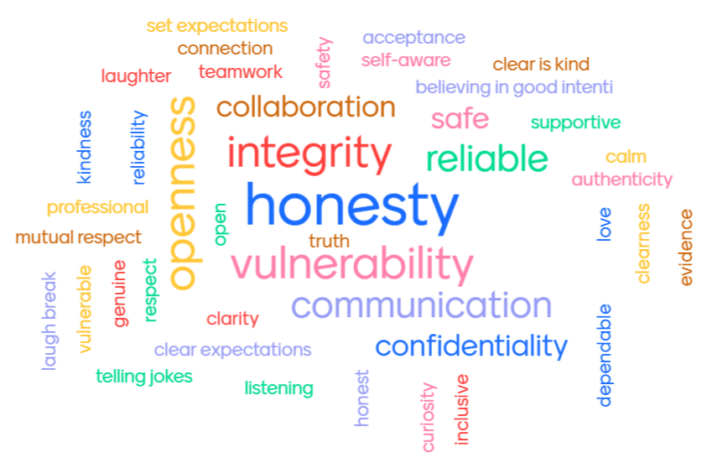

Trustworthiness and transparency definition- “Organizational operations and decisions are conducted with transparency with the goal of building and maintaining trust with clients and family members, among staff, and others involved in the organization.”

Source: <https://www.cdc.gov/cpr/infographics/6_principles_trauma_info.htm>

**Tip #1: Own Your Mistakes**

Why?

When a mistake is made, it can cause a break in trust. Owning the mistake and taking accountability for it creates an opportunity for reconnection and repair of trust. It also allows the mistake-maker to acknowledge what went wrong so that they can correct their action. The intention of the apology is not to find fault or blame but rather to support an improvement in the relationship.

How can we do it?

Ingredients of a (good) apology (from *Harriet Lerner’s Nine Essential Ingredients of a True Apology, Unlocking Us with Brene Brown):*

1. It does not include the word “but.”

2. It keeps the focus on your actions—and not on the other person’s response.

3. It includes an offer of reparation or restitution that fits the situation.

4. It does not overdo.

5. It doesn’t get caught up in who’s more to blame or who started it.

6. A true apology needs to be backed by corrective action.

7. It requires that you do your best to avoid a repeat performance.

8. Should not serve to silence others.

9. It does not ask the hurt party to do anything, not even to forgive.

Tip #1 additional resource:

Harrier Lerner and Brene Brown 9 Essential Ingredients to a True Apology

<https://brenebrown.com/art/harriet-lerner-and-brene-im-sorry-how-to-apologize-why-it-matters/>

**Tip #2: Laugh!**

Why? (From *Using Laughter To Build Trust At Work* by Brian Harman)

Laughter and trust are intertwined. Just consider how our bodies respond when we laugh–we raise the head back, exposing the neck, one of our most vulnerable parts of the body. Laughter is a physical signal of trust. We don’t laugh with people who threaten our safety, we laugh with the people we trust. Laughter can also be used to quickly create trust. The deeper the laugh, the greater the potential for trust will be. It’s important to be careful when cracking jokes, though. If someone’s lid is flipped, they might translate an opportunity to laugh WITH them as an attack or someone laughing AT them.

How can we do it? (from *How to Use Humor in Clinical Settings* by Paul Osincup)

1. Comedy commute: Listen to comedy rather than news on your commute.
2. Three funny things: Identify three things that you found funny or amusing each day.
3. Play the “what I could’ve said” game: If you miss an opportunity to say or do something funny in the moment, that’s ok–think about it after the fact. The more you do this, the more likely your brain will make those connections in the future.
4. Five-minute funny: Find five minutes to watch a funny video at some point throughout the day.
5. Follow funny: Flood your social media with laughter-inducing content by following funny pages.

Tip #2 additional resources:

Using Laughter to Build Trust at Work

<https://www.forbes.com/sites/forbescoachescouncil/2019/04/10/using-laughter-to-build-trust-at-work/?sh=4573065c43c9>

How To Use Humor in Clinical Settings <https://journalofethics.ama-assn.org/article/how-use-humor-clinical-settings/2020-07>

**Tip 3: Create Predictability**

Why?

Trauma creates an overactive stress system that is sensitive to threat/danger. When we know what we will be experiencing next (sensory, logistically, relationally) we give that safety system permission to slow down. Rember…for predictability to be trusted, it needs to be consistent!

How can we do it?

1. Create agendas or plans with both staff and patients so people know what to expect.
2. Communicate frequently and clearly. Clear is kind!
3. Define clear metrics to help support shared expectations and goals.
4. Prioritize goals and tasks so people understand what is most important to the team.
5. Establish clear roles so people are clear what they are responsible for and where they can hand off to the next teammate.
6. Minimize interruptions to encourage a focused environment.
7. Answer questions and validate people within your team and with those you support.
8. Create “predictable unpredictability.” Sometimes we don’t have all the answers. Acknowledging that can let others know they are not alone.

Tip #3 additional resource:

Building trust at work: Predictability in unpredictable times

<https://rachelhands.com/2020/08/18/building-trust-at-work-predictability-in-unpredictable-times/>