**Safety: Email Sequence**

Greetings all,

Over the last year, we have been working on becoming a Trauma-Informed & Resilience-Oriented Healing Organization. As we move into the next phase of this journey, we will be offering bi-monthly workshops for the champions team to help operationalize the principles of a trauma-informed approach: safety, trustworthiness & transparency, peer support, collaboration & mutuality, empowerment, voice, & choice, and strengths-based. CommuniCare’s DEI group will be leading the workshop focused on cultural, historical, and gender humility.

Each workshop will focus on one of the principles and will offer three action-oriented tips to help bring the principle to life. In addition, we will be sharing follow-up emails to reinforce those tips. Our first workshop together focused on safety. Below are some tips focused on safety.

**Safety definition**

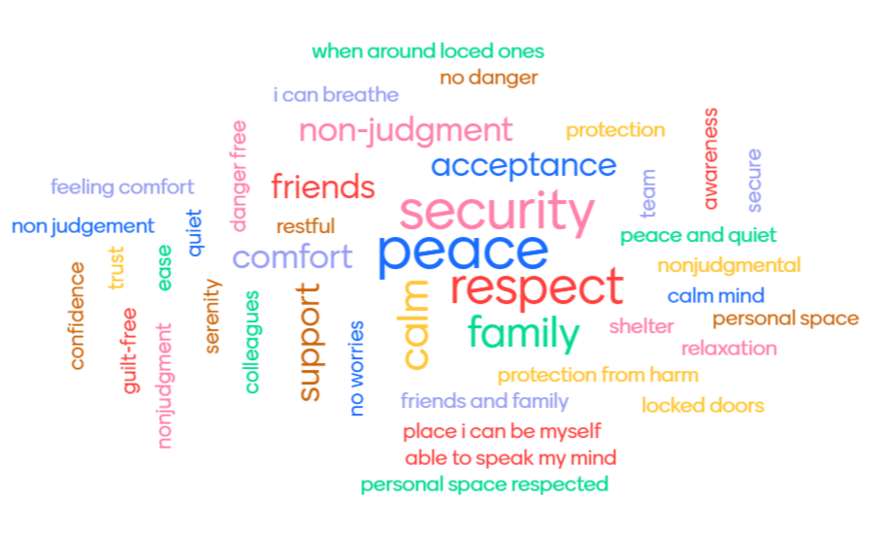

Throughout the organization, staff and the people they serve, whether children or adults, feel physically and psychologically safe; the physical setting is safe and interpersonal interactions promote a sense of safety. Understanding safety as defined by those served is a high priority.

Source: <https://www.cdc.gov/cpr/infographics/6_principles_trauma_info.htm>

**Tip #1: Incorporate Movement**

Why?

Incorporating movement before, during, and after a potentially high-stress experience is important to metabolize stress hormones internally and to help de-escalate the situation externally. When the mind has awareness of the body, we can move with intention through the stress cycle (remember the glitter jar) so that we don’t freeze or explode on those around us (remember the volcano). Those sensations of tension in the body exist for a purpose- to keep us safe! Movement helps us complete the stress cycle.

How can we do it?

1. Walking meetings - Whether in-person or virtual, walking during meetings can be a helpful way to get the blood flowing and to create a healthy workplace culture. Identify one way you can incorporate this into your weekly routine.
2. Get up and stretch (or jump around!) - For some of us, jumping is not an option and that’s ok. In between calls or even as a way to start a meeting, try stretching your arms to the sky, touching your fingers to your toes, or shaking out any tension and notice any changes you feel before and after.
3. Offer high 5’s, elbows - We are all in this together. Offering high 5’s or elbow taps throughout the day is a great way to get in your body and to connect with those around you. Challenge yourself to do this at least once a day.

Tip #1 additional resource:

Getting Started with Mindful Movement <https://www.mindful.org/getting-started-with-mindful-movement/>

**Tip #2: Set (and hold) healthy boundaries**

Why?

In creating a trauma-informed and resilience-oriented organization, we recognize the impact that trauma has on all of us. Trauma disconnects in unpredictable ways and removes a sense of agency and choice from a situation. A boundary can help us define how we are able to stay in relationship with another person and maintain a safe and healthy connection with those around us. As said by Prentis Hemphil, “Boundaries are the distance at which I can love you and me simultaneously.” Setting (and holding) healthy boundaries can look like a collaborative process including asking for preferences and permission. It can be flexible and it can be firm. It can help people feel heard and honored. As part of this, It is important to recognize the difference between real and perceived emergencies.

How can we do it?

1. Identify your boundaries: Before we can set a boundary, we need to be clear on what our boundaries are. As part of this process, we are identifying what we need to feel safe (emotionally or physically). You can identify a boundary when starting an interaction, in the moment when one has been crossed, or after an interaction with some reflection.
2. Communicate your boundaries (clear is kind): We can’t expect another person to know what our boundaries are if we do not tell them. How we communicate during that process matters–we can be both kind and firm. Remember that if someone is doing something that is crossing a boundary, their lid may be flipped. They may not know what is going on or they may be upset. It can be helpful to restate what you heard them say or do. Remember, the goal here is for them to hear your boundary so using lid-flipping language can get in the way of this process. Examples of phrasing include, “I am able to help you best when you are not yelling” or “I am grateful that you’re asking me and I’m not available that day/time” or “It sounds like this is really important and time sensitive. The best way to get help with this is to call five days in advance. I can’t help you get medication today.”
3. Hold your boundaries: The other person may continue the behavior or make another request. People may not always like the boundaries we create. It is important to remember that we cannot control the reaction of others to the boundaries we set. When we know our limits, we can choose how to respond to those limits not being met.

Tip #2 additional resource:

Boundaries with Brene Brown- <https://vimeo.com/274228723>

**Tip 3: Assume everyone is doing the best they can**

Why?

A trauma-informed approach assumes behavior is communication, often of an unmet need. When we can listen and observe with curiosity instead of judgment, we can view behavior through those trauma-informed lenses. It is much easier to do this when our own lids are not flipped!

How can we do it?

1. Try to relate to the other person (...like me). This does not mean approving of someone’s behavior (we can still set boundaries!) but rather relating to a feeling. Connection helps us get into and expand our own resilience zone.
2. Meet people where they are (if you’re not sure, ask!). Sometimes we have a solution to someone’s problem but they are not ready for it yet. They may need to be heard. Pause. Ask them, “What do you need right now? How can I best support you?”
3. Summarize with the phrase, “What I’m hearing you say is…” Another way to pause, connect, clarify, and stay curious is to recap what you heard someone say. You may want to reflect what you heard exactly or rephrase anything you aren’t certain of to gain clarification.

How (not) to do it…

1. Take it personally or judge
2. Start in the same place for everyone
3. Try to immediately problem solve

Tip #3 additional resource:

Empathy: The Human Connection <https://www.youtube.com/watch?v=cDDWvj_q-o8>