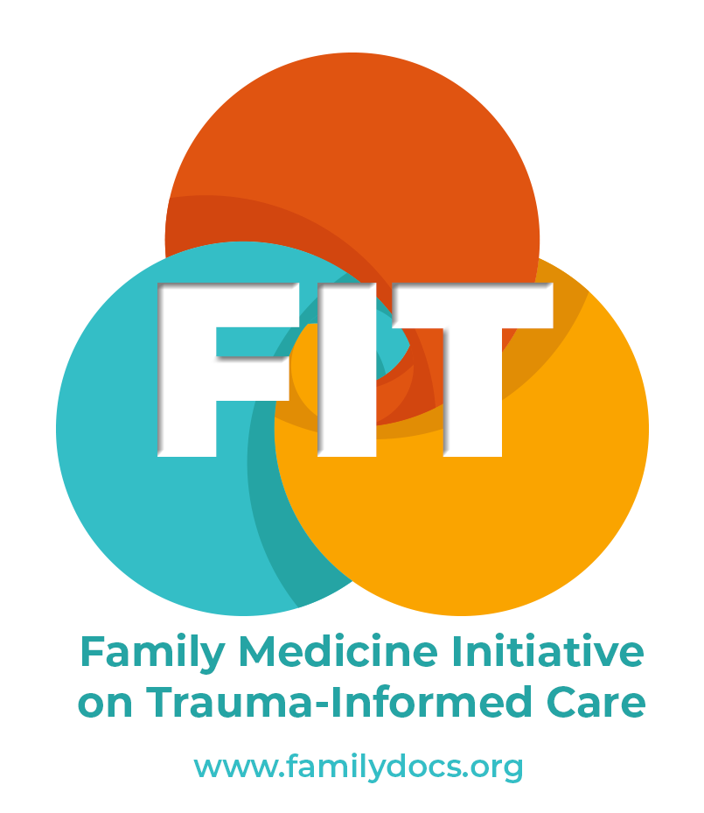
ACEs FIT Questions, Answers and
Resources

Issues/Questions | Ideas and Suggestions to Consider
I’m trying to visualize how to incorporate this into my practice in an effective manner. | As family physicians, we have all treated patients with trauma, we already know what to do to help our patients. Think of it as a way to say “I’m here” to your patients.
If I already know my adult patient has trauma in their lives, is there value to doing the screening? | Yes, there is still value. When you explain the screen and ask the questions, you reinforce for the patient that ACEs is a thing. There is relief in knowing that this is real, that others suffer, that there is an entire program and research that’s grown up around this, and that the larger community (schools, social services, etc.) has been engaged with this work for a long time. Your patients’ trauma may weigh on them. By listening empathetically, we can plant a seed for change.
Once I have the ACEs “number”, what do I do about it? | There is utility in doing the screen and arriving at a number, but it is not a diagnosis. Consider using the screening results as we use vital signs, to expand our differential diagnosis. If a patient has a fever, we think “infection”. If your patient has a high ACEs score, consider, “are my patient’s health problems a sign of toxic stress?” It is information that leads to understanding. Information that can be acted upon, over time, if the patient desires that.
What if I have challenges getting buy-in from other providers and staff? | You might share the ACEs FIT workshop materials with them and/or encourage them to take advantage of the recorded version of the ACEs FIT workshop. The trauma and ACE statistics are very compelling. The ACEs Aware Initiative has helpful information on their website, including an implementation roadmap. You might also remind them that patients who’ve undergone screening report higher levels of satisfaction with their healthcare. Remember that we strongly recommend implementing ACEs screenings within the larger context of trauma-informed care. This includes caring for providers and staff, along with their limitations and concerns.
Should I do this screening if I don’t have the staff or resources to follow-up on it? | This may require some reflection on how the proposed workflow will affect the patient experience, given available staffing. For example, what will be the patient experience if no one can call them with a check-in? The requirements for follow-up should be similar to other situations in primary care (e.g. is responding to an abnormal potassium level much different in staff time than checking in after a visit?)  Some patients really want the opportunity to share their past traumas but don't know how to approach it. Not all patients want treatment, sometimes the opportunity to share what happened to them and to receive acknowledgement is enough. If assistance is desired, you should use the same resources you already use to help your patients with depression, intimate partner violence, food insecurity, drug use, etc. Trauma-informed care practices are helpful for patients dealing with trauma or toxic stress.  Please do, however, ensure that you have a system in place that notices and acknowledges the screening with each patient. We strongly discourage screening in a setting where there is risk of a trauma disclosure going unacknowledged. You will also want to make certain that providers and staff are trained for this and that they have the personal coping skills to receive the information and acknowledge the patient’s situation. This is no different than what we strive for with all the healthcare we provide.
Are there specific patients/cases where these questions are particularly relevant? | Patients who are trauma-exposed tend to be the high utilizing, complex patients. Getting to the root of what may really be wrong is a way of making their care more precise and effective. ACEs insights can be particularly helpful in cases where there is no unifying diagnosis.
What is the appropriate next step after your patient discloses trauma? | A sufficient response to disclosure can be simple and brief. First, provide a validating, empathic acknowledgement, something along the lines of, “I’m so sorry that this happened to you, that sounds really difficult.” Then, rather than jump to thinking about interventions or therapeutics, ask a next question: “How much difficulty is this causing you in your current life?” Keep in mind that a patient might disclose past trauma to you and that might be it. They may not be open to seeing a therapist or a social worker right now; they might just want to talk with you. There is power in the conversation with the patient – just being seen and heard is therapeutic.
The complete questionnaire, all at once, could feel daunting to patients. | As in all trauma-informed care practices, we advise giving patients general information about the relevance of ACEs and then ask them for permission to screen. You also might consider leveraging the family physician’s longitudinal patient relationships and spread the questions out over multiple visits. Consider asking particular questions in a fitting context (e.g. the sexual abuse questions during a routine pelvic exam).
What about patient privacy - what are the potential ramifications of recording this information in a digital patient record? | One suggestion is to bundle the ACEs with PHQ in the EMR. You also might consider using the confidential sticky-note feature so that only the PCP can see the information. We strongly encourage using the De-identified ACEs Questionnaire so the system only records the number and not the patient’s specific trauma exposure.
Where will I find the time to do this screening in an already compressed schedule? | The ACEs questions are likely questions you already ask but are now asked in a more standardized and systematic manner. Remember, you don’t have to ask all these questions in one visit, nor does every patient want to do a deep dive into their past traumatic events. This practice can be empowering to patients, even if you have limited time and resources available. The average length of visit increase for a POSITIVE screen is five minutes. It will get easier as you develop and practice your approach to the screen. Adopting a trauma-informed care approach may save you time in the long-run – when your patient feels heard and understood, other aspects of their care will go more smoothly.
It will be particularly challenging to take the time for the screening when, to the patient, it may not seem connected to the reason for the visit. | Educating patients about the long-term health implications of trauma is part of the process. Once patients understand why this is important and relevant, it will make more sense to them. Finally, you may be the first person to ever ask a patient about these experiences—research has shown this can make patients feel better cared for and closer to their provider.
There just seems to be potential for trauma in every step of the process. | ACEs screening must go hand in hand with trauma-informed care. These concerns can be addressed or resolved when screening includes consent for screening, ensuring response to disclosures of trauma, assessing for safety, and educating on the effects of trauma.
I worry about re-traumatizing my patients by asking these questions. | Asking these questions isn’t usually the problem, particularly if the de-identified screen is used. What is retraumatizing is being asked to recount the details of the trauma. You can practice a trauma-informed approach without eliciting the details of your patients’ past traumatic events. The evidence shows that most trauma-survivors want to be sensitively asked about their histories. For our purposes, in family medicine, the exact details don’t matter as much as the fact that something terrifying or horrible happened to our patient. Many of our adult patients have been “carrying” these burdens for years and can be relieved to share them. Asking about ACEs and providing universal education about their association with chronic health conditions, can be empowering for patients. For the first time, they may have an explanation about what is going on with them. Patients respond to being seen.  Remember that ACEs are not destiny. All ACEs are not the same and each patient has different levels of resilience and protective factors. This is why we should never assume that a high ACEs score means that a patient is highly traumatized. Likewise, we should never assume that a low score means they are not at all traumatized. The key is to ask the patient how their experience impacts them.
But we don’t know what effective interventions there are at this point. | We listen, intervene, and refer as we would for other challenges our patients experience. But, yes, there is much more to be learned in order to develop best practices around ACEs and assure the best possible outcomes. We are all pioneers here! Embedding ACEs screening in the greater framework of trauma-informed care will assure that we do no harm and help our patients, while staying humble and open to learning more.

Resources

TRAUMA-INFORMED CARE
Female Pelvic Exam Guideline |  | These questions and methods are designed to gather information and alleviate the female patient’s anxiety by establishing rapport.
Male Pelvic Exam Guideline |  | These questions and methods are designed to gather information and alleviate the female patient’s anxiety by establishing rapport.
Trauma-Informed Care Toolkit |  | From the TIC Collective in Alberta, Canada, a collection of videos, papers, and other resources about TIC.
SANE |  | RNs who have special training for interacting with patients who have experienced sexual assault.
SAMHSA Concept of Trauma and Guidance for a Trauma-Informed Approach, |  | A free, 27-page PDF booklet offering a framework for becoming a trauma-informed organization or service. Emphasis on implementation.

PARENTING/FAMILY
UCSF Family Services - videos | Videos of past events sponsored by UCSF family services.
Positive Discipline Community Resources | Sample schedules, routine charts, suggested activities for families to try
First 5LA | Information and resources organized by parenting topic (e.g. discipline, behavior, bonding, literacy, school readiness, etc.)
Sound Discipline | Wonderful parenting resources and tips, including a curated list of resources by topic
AAP Family and Caregiver Resources | Education and support for families around resilience building
Parenting Toolkits and Guides | A collection put together by ACEs Aware
Safe, Secure, and Loved | A program developed by psychologist, Dr. Barbara Burns. Includes educational materials based on current research evidence, teaching six habits of resilience.
Resilience: The Biology of Stress and the Science of Hope | This James Redford film (1 hour) does a wonderful job of explaining the biology of toxic stress and the importance of resilience to buffer it.

NATIONAL RESOURCES
AAFP EveryONE Project | Education and resources to help you advocate for health equity, including the Neighborhood Navigator for finding resources in your area.
One Degree | Look up engine for free, life-improving resources under the categories of family, food, health, housing, education, legal, employment, and money.
Alcohol & Addiction Anonymous (AA) Meeting Finder | Meeting finder.
Al-Anon and Alateen Family Group Meeting Finder | Meeting finder.
Alateen Family Groups | A fellowship organization for young Al-Anon meetings (12-18 yo) whose lives have been affected by someone else’s drinking.
Harm Reduction Institute | Organization to build power and equity with people who use drugs
Children’s Institute | Family planning, counseling, parenting classes
Mindoula | Telehealth behavioral services
Concert Health | Telehealth behavioral services

APPS AND ONLINE COURSES
Mindfulness Meditation Apps | UCLA Mindful App, Breathe, Headspace, Mindfulness , My Life, Mindfulness Coach (developed by the U.S. VA). These are all available as free downloads.
Global Hope Challenge | An online, free, ten-day course to help develop skills to create, maintain, and grown hope in your life.

PODCASTS
Sleep With Me | Innovative audio solution to adult insomnia featuring lulling, droning, stories to calm your thoughts, with stream of consciousness tangents that mimic the way your brain works in the moments between waking and sleeping.
Terrible, Thanks for Asking | Compassionate and heartbreaking true stories about people who’ve experienced trauma and how they’ve coped
Un F*ck Your Brain | Non-nonsense insights into the ways your anxious brain might be sabotaging you and actionable advice on how to choose different thoughts.
Radio Headspace | A podcast spun out of the popular meditation app (Headspace) that focuses on navigating post-pandemic life.
The Anxiety Coaches Podcast | Relaxing and inspiring show sharing lifestyle changes to calm you and help heal.
Life after PTSD | Shared stories from people who have suffered traumatic events and how they created a life for themselves in the face of that.

BOOKS
The Body Keeps the Score: Brain, Mind, and Body in the Healing of Trauma | Bessel van der Kolk ©2014
The Betrayal Bond: Breaking Exploitive Relationships | by Patrick Carnes
What Happened to You? Conversations on Trauma, Resilience, and Healing | by Oprah Winfrey and Bruce Perry
The MindBody Workbook | by David Schechter. A 30-day structured journal to identify and heal from psychologic issues that may be causing physical pain.

ACES AWARE RESOURCES
ACEs Aware Provider Training | Training for ACEs screening provided by ACEs Aware
ACEs Aware resource site | The root page to get started on all resources provided by ACEs Aware
ACEs Aware Provider Toolkit | 67-page PDF explaining the initiative, screening, treating, and healing. Includes patient tools.
The Story of Your Number | A short (1:28), patient education video on understanding your ACEs score.
The California ACEs Academy | Free live and on-demand webinars from national experts on ACES and TIC.
ACEs Science Research | Research resources and citations for the science behind ACEs
Trauma-Informed Guides, Presentations and Self-Assessment Tools | A vetted guideline and tool collection from various national organizations
Trauma-Informed Therapists | Lists and databases to help direct you to trauma-informed therapists across the country
Patient Tools and Informational Handouts | Ready-to-print handouts on sleep, relaxation techniques, meditation, exercise, parenting, etc.
Spanish Language Resources | From ACEs Aware

