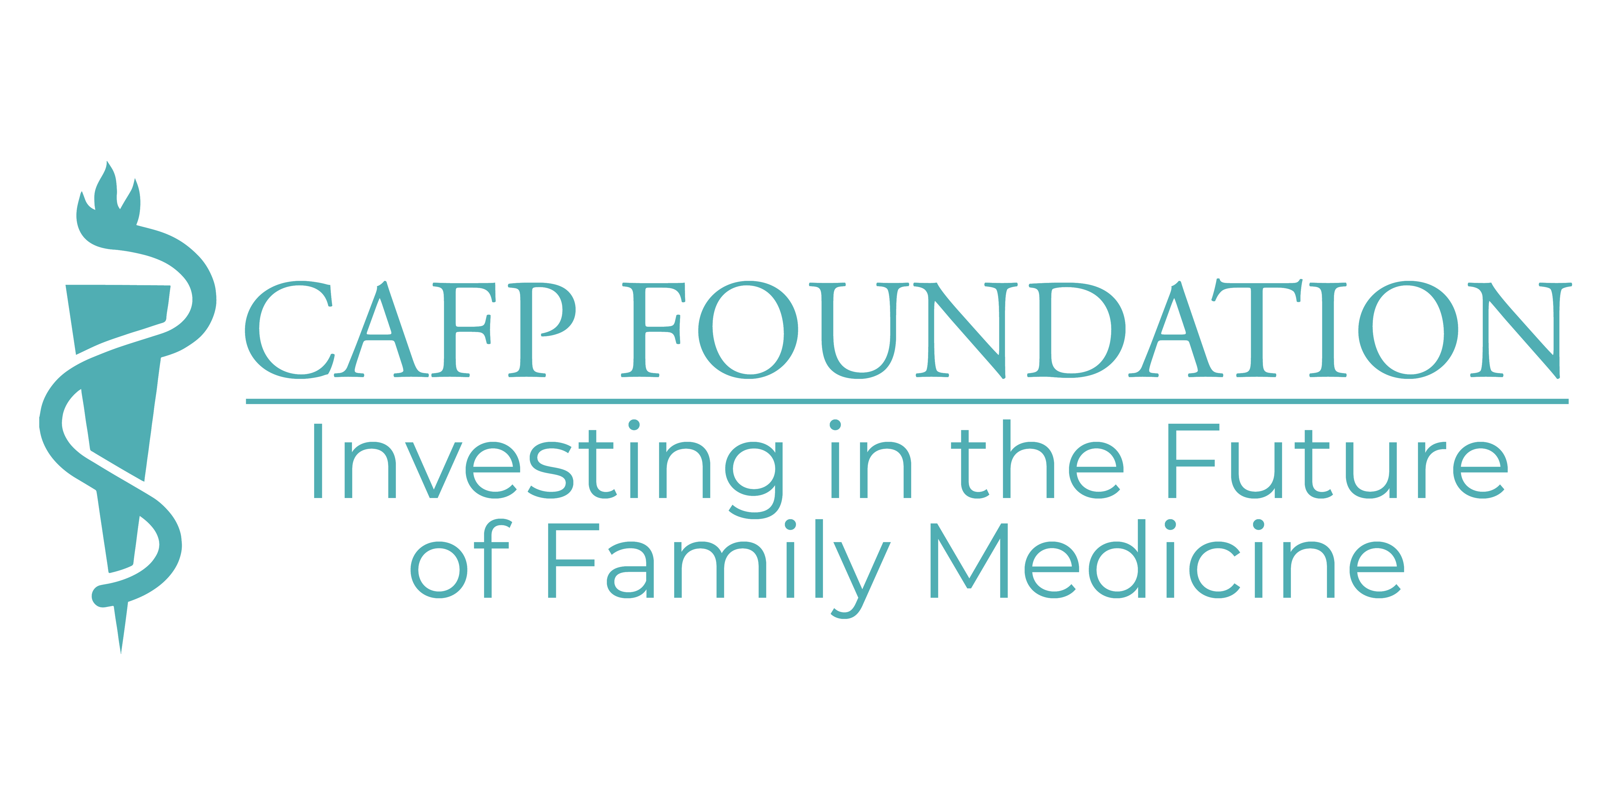
CALIFORNIA ACADEMY OF FAMILY PHYSICIANS FOUNDATION
ANNUAL AWARDS and PAST RECIPIENTS

Award for Educational Excellence in Honor of Barbara Harris

This award recognizes educational excellence in the field of family medicine. The Barbara Harris Award was established in 1984 to honor the late Ms. Harris, a former Executive Director. The award was renamed, with an enhanced focus, in 1996. The Award for Educational Excellence in Honor of Barbara Harris highlights achievements in education, a field very important to Ms. Harris.

One individual will be honored annually with this award. The award is presented to an individual working in California who demonstrates excellence in advances in education in the field of family medicine; family medicine teaching in medical schools, residency programs and/or post-graduate CME. The recipient should also be actively engaged in CAFP educational initiatives, from clinical to practice transformation to advocacy.

1984 Ransom B. Turner, MD
1985 Merrill Werblin, MD
1986 John Crivaro, MD
1987 Edward Neal, MD
1988 Harrison McCandless, MD
1990 Richard Barnett, MD
1991 Stephen Brunton, MD
1995 Hugh Upton, MD
1997 John Dervin, MD
1998 George Kent, MD
1999 Alex Sherriffs, MD
2000 Jimmy Hara, MD
2001 Francesca Taylor, MD
2002 Ellen Beck, MD
2003 Tim Munzing, MD
2004 Marianne McKennett, MD
2005 Margaret McCahill, MD
2006 Michael Prislin, MD
2007 Peter Sommers, MD
2008 Susan Melvin, DO
2009 Carol Havens, MD
2010 Cecelia Gutierrez, MD
2011 J. Dennis Mull, MD
2012 David E.J. Bazzo, MD
2013 Thomas Bent, MD
2014 Lauren Simon, MD, MPH
2015 JoMarie Reilly, MD
2016 Gilberto Granados, MD
2017 Lance Fuchs, MD
2018 Dereck DeLeon, MD
2019 Kristin Brownell, MD
2020 Christopher Flores, MD

Award for Excellence in Family Medicine Research

Our research recognition award will identify one individual who exemplifies excellence in family medicine research through their own studies, or through efforts to promote and support research in family medicine. Recognizing such an individual sets a standard of excellence and provides a positive and inspiring example for others to follow.

One individual will be honored annually with this award, assuming qualified nominees are received. The award is presented to an individual working in California with a proven record of supporting and promoting research in family medicine, encouragement and motivation to others to become researchers and participation in family medicine research.

2001 Lillian Gelberg, MD, MSPH
2002 Ted Ganiats, MD
2004 Kevin Grumbach, MD
2006 Michael Rodriguez, MD, MPH
2007 David Folsom, MD
2010 Mimi Tarn, MD

Philanthropist of the Year Award

A fully integrated recognition program moves the donor along a path of heightened awareness and involvement. Our premier recognition program is the identification of one individual (or couple) who exemplifies the spirit of philanthropy through extraordinary support of family medicine. Recognizing such an individual (or couple) sets a standard of excellence and provides a positive and inspiring example for others to follow.

One individual (or couple) will be honored annually with this award of exceptional generosity who, through direct financial support, has demonstrated outstanding civic and charitable responsibility, and whose generosity encourages others to take philanthropic leadership roles on a community, state and/or national level.

2000 Dr. and Mrs. Norbert Hillecke
2001 Dana Ware, MD
2002 John Crivaro, MD
2004 Ronald Bangasser, MD and Susan Bangasser, PhD
2006 Yushu Jack Chou, MD
2010 Jimmy Hara, MD

CAFP Foundation Resident of the Year

In 2010, the CAFP Foundation bestowed its first Resident of the Year Award to a resident who represents the finest characteristics of family medicine, including a commitment to leadership, communication, mentorship and advocacy. The winner of this award is selected by the CAFP Foundation, with input from the Medical Student and Resident Leadership Councils, local chapters, and others,

2010 Veronica Jordan, MD
2011 Ashby Wolfe, MD, MMP
2012 Alisha Dyer, DO, Charlene Hauser, MD, MPH, and Randi Sokol, MD, MPH
2013 Raul Ayala, MD
2014 Daniel Pio, MD
2015 Aaron Edelstein, MD
2016 Alex Mroszczyk-McDonald, MD
2017 Laura Doan, MD
2018 Isabel Chen, MD, MPH
2019 Robert Assibey, MD and Romero Santiago, MD, MPH
2020 Lulua Bahrainwala, MD

CAFP Foundation Preceptor of the Year

In 2013, the CAFP Foundation founded the Preceptor of the Year award to celebrate the many family physicians who take medical students and residents into their practices, and into their lives. This award honors more than the “rotation” encounter; it celebrates the time and commitment our preceptors and mentor give to the future of our specialty.

2013 Alex [Sandy] Sherriffs, MD and Joan Rubinstein, MD

2014 Thomas Bent, MD
2015 Stephen Lin, MD

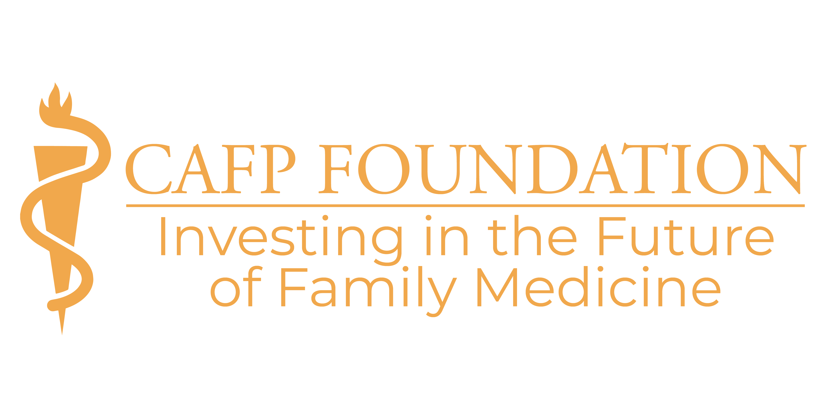

CALIFORNIA ACADEMY OF FAMILY PHYSICIANS FOUNDATION
ANNUAL AWARDS NOMINATIONS

Please return this form and accompanying materials no later than February 1, 2021.
CAFP Foundation, 1520 Pacific Avenue, San Francisco, CA 94109, fax: 415-345-8668
or email: cafp@familydocs.org

Your name:
Your phone: Your email:

I’m pleased to nominate the following individual for a 2021 CAFP-F Award!

Name:
Position/Title:
Organization (if appropriate):
Address/C/S/Z:
Phone: Fax:
Email:

Award (check the appropriate award)
- Award for Educational Excellence in Honor of Barbara Harris
- Award for Excellence in Family Medicine Research
- Award for Preceptor of the Year

Please review the criteria for submission in the Awards Description and send the required elements with your nomination.

- Nomination Letter: Include a description of why you are nominating the individual and what in particular, makes the nominee deserving of the award.

- Letters of Support (2 minimum and 5 maximum): Try to obtain letters of support from students, colleagues, members of the community and/or others directly involved in the nominee’s endeavors.

- Nominee’s Current CV and Photo (digital): A brief summary is sufficient. Maximum 10 pages!

